19th South West Public Health Development School
Integration and Collaboration
Imperial Hotel, Torquay 22-23 September 2015

Day One Programme – Tuesday 22nd September 2015
0945 | Registration opens with tea and coffee  Sign up for workshops | Main Reception area/Palm Court
1030 | How can Public Health Integrate and Collaborate? Maggie Rae, Head of School, Ayo Oyinloye, Training Programme Director, SW Public Health Training Programme.  Natalie Field, Interim DPH, North Somerset, Kelechi Nnoaham, DPH Plymouth | Torbay Suite
1100 | Plenary introduction – Kate Blackburn, Specialty Registrar in Public Health  Plenary - Paul Mears, Chief Executive, Yeovil District Hospital, ‘The Symphony Programme – new models of care for a healthier population’ | Torbay Suite
1140 | Tea and coffee available in workshop rooms
1145 | Workshop 1a - Proactive People Management | Regency Room
 | Workshop 1b - All you need to know about NHS Finance and Budgets, and why it’s important to me | Gold Room
 | Workshop 1c - Real World Evaluation - Part 1 | Haldon Room
1315 | Lunch | Regatta Restaurant
1415 | Workshop 2a - Antimicrobial resistance | Regency Room
 | Workshop 2b – Behind the scenes, how did Bristol win the status of ‘European Green Capital 2015’ | Gold Room
 | Workshop 2c - Real World Evaluation - Part 2 | Haldon Room
1540 | Tea and coffee available for plenary | Torbay Suite
1545 | Plenary introduction - Yoav Ben Shlomo, Academic Consultant in Public Health  Plenary - Laura Nicholas – Director of Operations and Assurance, NHS England South West ‘Integration and Collaboration and what it means for Public Health’ | Torbay Suite
1630 | Fringe a - PH lifestyle team - Bay walk | Meet at Hotel reception
 | Fringe b - PH lifestyle team - Bay run | Meet at Hotel reception
 | Fringe c – Meditation and Mindfulness | Regency Room
1730 | Free time
1830 | Pre-dinner drinks | Palm Court
1900 | Seating for dinner | Torbay Suite
1915 | Presentations | Torbay Suite
1930 | Dinner | Torbay Suite
2100 | Music and entertainment - The Smooth Operators and Maggie Reeday' along with a Jive lesson from Matt Edmunds | Torbay Suite

Day Two Programme – Wednesday 23rd September 2015
0800 | Breakfast for guests | Regatta Restaurant
0915 | Registration open with tea and coffee  Sign up for workshops | Main Reception area/Palm Court
0945 | Plenary introduction - Zoe Clifford, Specialty Registrar in Public Health  Plenary – Charlotte Moar, Programme Manager NHS Wales Finance Academy - The value of Public Health and Finance working together | Torbay Suite
1030 | Morning break with tea and coffee | Palm Court
1045 | Workshop 3a - Improving Workplace Health | Regency Room
 | Workshop 3b - What is the value of Social Prescribing? | Gold Room
 | Workshop 3c - Revalidation and Professional Appraisal update | Haldon Room
1215 | Lunch | Regatta Restaurant
1315 | Workshop 4a - Managing communications in the right way helps enhance and maintain a good reputation | Regency Room
 | Workshop 4b - Understanding Cyber -Crime Resilience | Gold Room
 | Workshop 4c - Spatial Planning: ‘what could a ‘healthy’ town look like? | Haldon Room
1445 | Question Time session (with tea and coffee) – Panel:- Caroline Dimond, Maggie Rae, Selena Gray, Mark Pietroni | Torbay Suite
1600 | Finish

19th South West Public Health Development School
Integration and Collaboration
Imperial Hotel, Torbay 22-23 September 2015

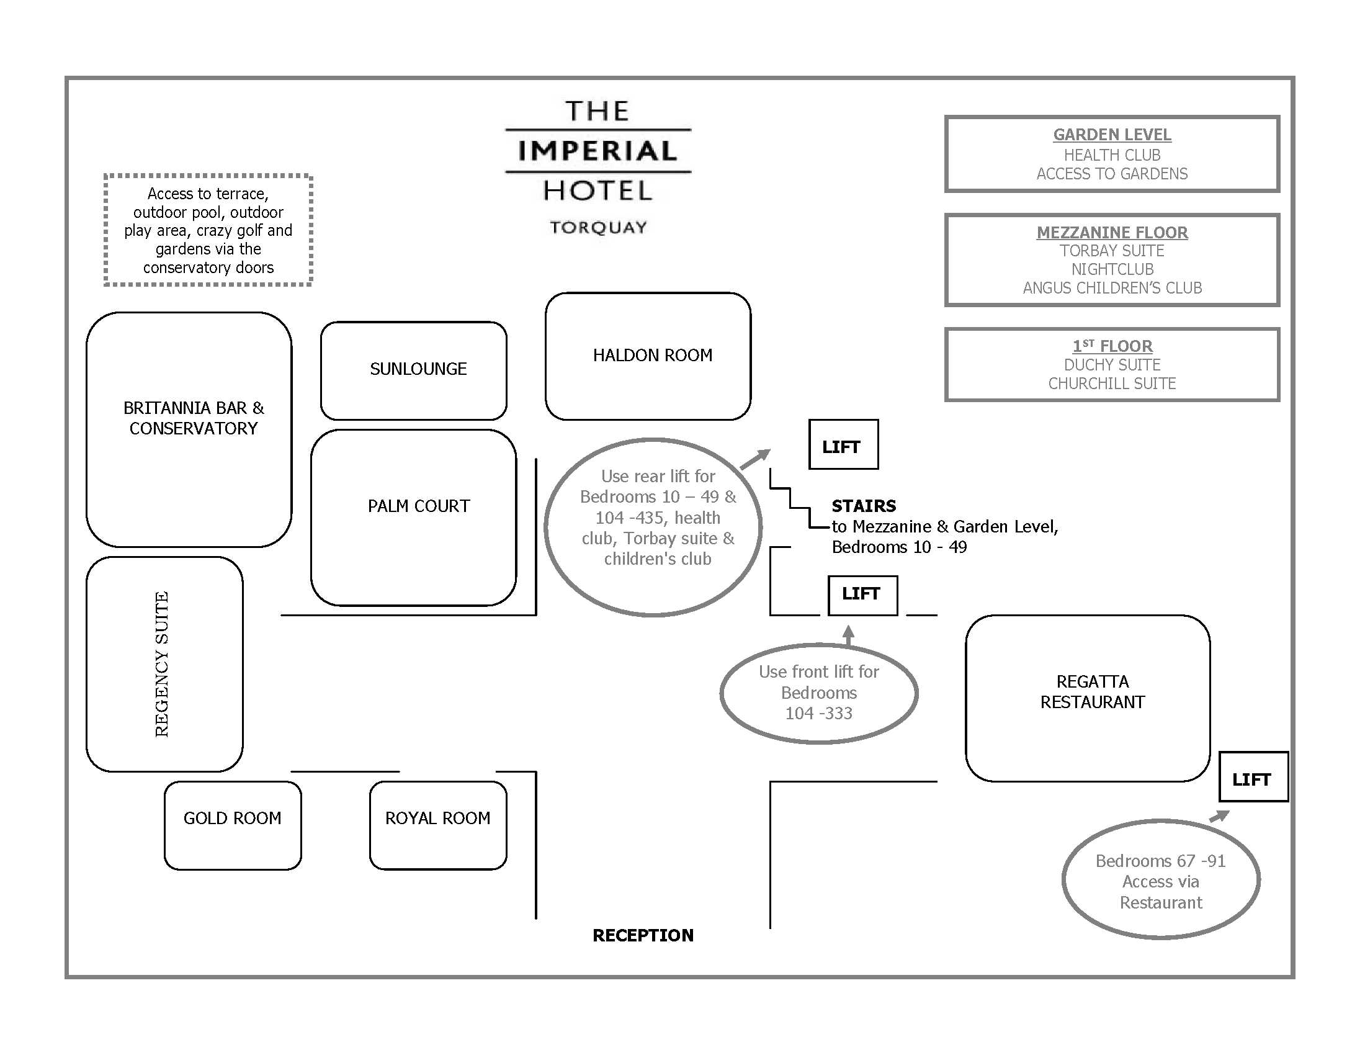

19th South West Public Health Development School
Integration and Collaboration
Imperial Hotel, Torquay 22-23 September 2015

TUESDAY 22ND SEPTEMBER 2015
WORKSHOP INFORMATION

WORKSHOP SESSION ONE
1145 - 1315

1A - Proactive People Management
Aims: To enable participants to feel confident in managing performance ( good or bad ) to a positive outcome

Learning Outcomes: Learn about Tools and techniques for getting the best from People ( for example planned spontaneous recognition ) Explore our cognitive bias in having those “ difficult “ conversations and how to be the most effective we can be. Understand frameworks for managing and addressing performance issues.

An interactive workshop that will involve participants in group work, sharing their views and experiences ,and possible role play ( dependant on participant numbers )
Workshop leaders:
Paul Maisey MBA , Chartered MCIPD, Director Advanced Business Performance Ltd

1B - All you need to know about NHS Finance & Budgets; and why it’s important to me!

Aims: This is a whistle stop overview of NHS Finance designed specifically for non-NHS & non-Finance employees.

The session comes highly recommended by the Public Health SpR trainees who specifically asked that Paul be asked to come back and run the session at the Summer school for their P.H colleagues.
It is guaranteed to be interesting and thought provoking.

Learning Outcomes: Having attended this session, Public Health professionals will be better able to understand how NHS finance works, current and future challenges and how Public Health might be able to help influence change. In addition, Debbie will describe the transition of PH funding from the NHS to Local Government and current issues.

Main part will be run by Paul Crocker, using Powerpoint presentations, and audience participation. Questions are encouraged but please note, this is a whole day’s course squeezed into an hour and a bit! Depending on timing, there may be a case study at the end of the session for delegates to complete in the lunch break.
Workshop leaders:
Paul Crocker, ACMA. Assistant Director of Continuous Improvement, South Devon Healthcare NHS Foundation Trust
Debbie Stark, Deputy Centre Director SW PHE

1C – Real World Evaluation (Part 1)
Aims: To introduce participants to the principles of evaluating non-NHS public health interventions in real world settings

Learning Outcomes: To be able to decide on:
- When research is needed, and when it isn’t
- What is a researchable question
- How to match study designs to research questions, and
- Where to go for further information
In Part 1, at least half of the 90mins session will involve discussion with participants, obtaining their perspectives on the above issues, and their experiences of doing evaluation. Matt Egan and Yoav Ben-Shlomo will also give a few short presentations to raise issues for discussion and to give real-life examples. In Session 2 Elizabeth McGill will lead a 90min practical session on designing an intervention - participants will work together in small groups.
Please note delegates need to attend both Part 1 and Part 2

Workshop leaders:
Matt Egan, Senior Lecturer, London School of Hygiene and Tropical Medicine
Elizabeth McGill, Research Fellow, London School of Hygiene and Tropical Medicine
Yoav Ben-Shlomo, Professor, School of Social Community Medicine, University of Bristol

TUESDAY 22ND SEPTEMBER 2015
WORKSHOP INFORMATION

WORKSHOP SESSION TWO
1415 - 1545

2A – Antimicrobial resistance
Aim: The overall aim of the workshop is to describe epidemiological, health protection and public health microbiological aspects of antimicrobial resistance, and relate these to public health practice

Learning Outcomes:
- Understand the basics of mechanisms and clinical significance of resistance
- Appreciate the epidemiology of multi-resistant organisms and strengths and limitations of current surveillance systems
- Understand the role and function of antimicrobial stewardship in slowing the development of drug resistance
- Learn the key health protection actions described in the PHE toolkits for managing carbapenemase-producing Enterobacteriaceae in acute Trusts and non-acute and community settings

Three 15-20 minute presentations (targeted on 1-3 above), with a group discussion of the toolkits thereafter. An interactive and discursive approach will be used throughout the workshop.
Workshop leader:
Charles Beck, Consultant Epidemiologist and Honorary Senior Lecturer, Public Health England
Li Chin, Consultant in Infection (Medical Microbiology), North Bristol NHS Trust

2B – Behind the scenes, how did Bristol win the status of ‘European Green Capital 2015’

Aim: Human health is inextricably part of the health of the earth’s ecosystems; for the air we breathe, our water, food, shelter, security and meaning. This workshop will explore how by linking health and sustainability – like twins – public health has been part of Bristol’s green capital work, for 2015 and beyond

Learning Outcomes: Insight into the power, and the difficulties, of the ‘green’ agenda
Understanding of the obstacles that can make it hard to combine the health and sustainability agendas. Enthusiasm for bringing sustainability issues into the public health and inequalities agenda.
The workshop will be a mixture of talk/think/do. It will be participative and with some delivered content.
Workshop leaders:
Angela Raffle, Consultant in Public Health/ Honorary Senior Clinical Lecturer, University of Bristol Dept of Social Medicine

2C – Real World Evaluation (Part 2)
Aims: To introduce participants to the principles of evaluating non-NHS public health interventions in real world settings

Learning Outcomes: To be able to decide on:
- When research is needed, and when it isn’t
- What is a researchable question
- How to match study designs to research questions, and
- Where to go for further information
In Part 1, at least half of the 90mins session will involve discussion with participants, obtaining their perspectives on the above issues, and their experiences of doing evaluation. Matt Egan and Yoav Ben-Shlomo will also give a few short presentations to raise issues for discussion and to give real-life examples. In Session 2 Elizabeth McGill will lead a 90min practical session on designing an intervention - participants will work together in small groups.
Please note delegates need to attend both Part 1 and Part 2

Workshop leaders:
Matt Egan, Senior Lecturer, London School of Hygiene and Tropical Medicine
Elizabeth McGill, Research Fellow, London School of Hygiene and Tropical Medicine
Yoav Ben-Shlomo, Professor, School of Social Community Medicine, University of Bristol

TUESDAY 22nd SEPTEMBER
FRINGE SESSIONS

1630 - 1730

FRINGE A – Bay Walk
Bay Walk

2 walks are offered both starting at the Imperial Hotel at 16.30

Walk 1:
Leaving the Imperial Hotel, this walk will go around the harbour and pick up the South West Coast Path to walk along the seafront to the pedestrian bridge. The walk will then return to the Imperial Hotel.
This is a walk of approx. 2 miles, all on level ground. The terrain is concrete and most footwear is suitable.
There is the option to stop for a drink at one of the cafes along the seafront before the return walk.
Walk Leaders - Elaine Mason & Wendy Wilkinson

Walk 2:
Leaving the Imperial Hotel, this walk will follow the South West coastal path to Daddyhole Plain and Meadfoot beach. At the car park at the far side of the beach, the walk will turn around for the return journey. Return will be via pavements before turning into St Johns Wood. This route will also go down some steps shortly before returning to the hotel.

This is a walk of approx. 2.5 miles on varying terrain. Suitable footwear should be worn.
Walk Leaders - Rod & Maggie Wilson

Maps will be available on the day.

Please meet leaders at the Hotel Reception.

Session facilitators:
Andrew Simpson, Deputy Service Manager, Healthy Lifestyles Torbay and Southern Devon Health and Care NHS Trust

FRINGE B – Bay Run
There is no specific leader for this run.

Delegates are able to run this path rather than walk.

Leaving the Imperial Hotel, this run will go around the harbour and pick up the South West Coast Path to run along the seafront to the pedestrian bridge. The run will then return to the Imperial Hotel.
This is a run of approx. 2 miles, all on level ground. The terrain is concrete and most footwear is suitable.
There is the option to stop for a drink at one of the cafes along the seafront before the return run.

Maps will be available on the day.

Session facilitators:
Andrew Simpson, Deputy Service Manager, Healthy Lifestyles Torbay and Southern Devon Health and Care NHS Trust

FRINGE C – Meditation and Mindfulness
Meditation and Mindfulness Learning Workshop

I would like to offer colleagues an introduction to meditation practices and mindfulness. I am a regular meditator and have developed my own meditation practices over many years – see more details about me below.
The session will be for 50 minutes and will aim to cover the areas listed below. It will be relaxed and practical with a few inputs, brief discussions and lots of having a go at basic meditation techniques and activities. During it you will learn how to progressively relax your body, help your mind to become still and focus your attention. I will explore a few different approaches so that you can choose those which work well for you.
- Meditation Basics
  - breathing freely and managing the breath (use Buddha’s 8 lines and Patanjali’s teachings)
  - quietening the mind
  - accepting the world

- Managing ourselves in meditation
  - loving oneself
  - being open to receive
  - knowing myself

- Growing through meditation
  - being in bliss
  - chakras and energy flow
  - mindfulness

Although I have a degree in theology and am fully trained as a vicar, I have for many years used Transcendental and Buddhist based meditation practices. I find that regular meditation keeps me focused and grounded and particularly use it when I am anxious about life or training events I am about to deliver. My practice has developed over many years – initially I focused on breathing based practices and clearing the mind but after attending a week long Buddhist retreat I adopted more Buddhist based processes into my regular routines such as ‘metta bhavana’ (kindly awareness and loving thoughts towards others) and more developed breathing rhythms. I have since then embraced other techniques including focussing on chakras (energy centres in the body) and various types of visualisation and imagining. I am particularly interested in the development and use of ‘Mindfulness’ (derived from Buddhist meditation) in contemporary mental health and well-being practices and am currently following a programme of meditation development devised by John Selby.

Session facilitators:

Workshop leader: Alan Cook (Head of Medical Education and Faculty Development, Severn PGME)

WEDNESDAY 23rd SEPTEMBER 2015
WORKSHOP INFORMATION

WORKSHOP SESSION THREE
1045 - 1215

3A – Improving Workplace Health
Aims: To share information about the approach that the PH team in Wiltshire Council has taken to improving workplace health, via the Workplace Charter

Learning Outcomes:

- Concepts of workplace health
- Approaches to delivering workplace health
- Barriers and facilitators
- Understanding of the Workplace Charter

The workshop will be include Presentation and Quiz, followed by Q&A session
Workshop leader:
Frances Chinemana, Associate Director Public Health, Wiltshire Council

3B – What is the value of Social Prescribing?

Aims: The aim of the workshop is to provide an introduction to the term social prescribing. It will provide participants with an opportunity to consider how we can measure value.
Learning outcomes:
1. Understand different types of social prescribing;
2. Discussion and delineation of potential impacts of social prescribing;
3. An exploration of different impact measures;
4. A brief introduction to assessing social value through a Return On Investment approach;
5. An assessment of what commissioners might need to invest in social prescribing initiatives

The purpose of the workshop will be to engage participants in discussing social prescribing. The aim is to share experiences utilising stimulus material provided by the facilitator.

Workshop leaders:
Richard Kimberlee, Senior Research Fellow, Lead Director of the Integrative Medicine HIT. University of West of England

3C – Revalidation and Professional Appraisal update
Aim: To bring participants up to date on revalidation for those on GMC, UKPHR, GDC and NMC registers

Learning Outcomes:

To understand the expectations and requirements of the 4 professional groups around Professional appraisal and revalidation

This workshop will include factual presentation and/or handout plus quiz and opportunity for questions
Workshop leaders:
Judy Curson, Public health consultant – workforce, Public Health England South West
Nicola Wong, Executive Officer, Public Health England

WEDNESDAY 23rd SEPTEMBER 2015
WORKSHOP INFORMATION

WORKSHOP SESSION FOUR
1315- 1445

4A – Managing communications in the right way helps enhance and maintain a good reputation
Aims: To explore how good, joined up communication helps maintain and enhance the reputation of
an organisation.

Learning Outcomes: To demonstrate how working with partner organisations when communicating helps enhance the reputation of all involved. To help identify how and when to communicate to relevant audiences - including through social media

This workshop will be an Interactive learning session looking at real life examples.
This will include working in small groups.
Workshop leaders:
Allan Clarke, News and Information Officer, Wiltshire Council

4B – Understanding Cyber Crime Resilience
Aims: To raise awareness of what is cyber-crime and to open a discussion on how prepared we are and how we would respond to a cyber-attack across public health.

Learning Outcomes:

- An understanding of what is cyber-crime and how your work and organisation could be affected.
- Improved knowledge of key prevention steps that you could take to protect yourself/organisation against cyber-crime.
- An improved understanding of how you and your organisation would respond to a cyber-crime incident.

Workshop will include a 25 minute presentation introducing and defining what cyber-crime is. This would be followed by a 40 minute workshop looking at real world scenarios and discussing how organisations would respond.
Workshop leaders:
Deborah Haynes, Consultant in Public Health (Designate), Wiltshire Council
DI Gavin Webb, Detective Inspector - Regional Cyber Crime Unit
DS Aled Jones, Detective Sergeant – Regional Cyber Crime Unit
Dan Masters, Cyber Crime Investigator

4C – Spatial Planning: what could a ‘healthy ‘ town look like?
Aims: To explore the role of public health in spatial planning

Learning Outcomes:

To understand the role of public health in spatial planning
To explore the benefits and challenges of influencing planning in local authorities
To work on a real life example for a 6,000 unit development in Swindon
To share experience in developing expressions of interest in response to the NHS Forward View into Action call for the healthy new towns programme
To explore ways to collaborate more closely between local authorities, planners, developers and the NHS

The workshop will include:

- Presentation on spatial planning and public health - the journey so far and future opportunities (10 mins)

- Presentation on Wichelstowe – 10000 new people for Swindon and building health in from the start (10 mins)

- Creative and innovative thinking: pushing boundaries (5 mins)

- Delegate participation – ‘designing for real’ to focus on:
- designing homes that support independence at all stages of life
- designing inclusive public spaces that enable people of all ages and abilities from all backgrounds to mix
- designing an integrated health system that combines physical health, mental health and social care
- designing environments that encourage healthy behaviours

This will involve 4 groups working creatively on each of these areas (30 mins). Within each group people will be encouraged to take on specific roles and to discuss / debate from this perspective – roles to include a public health professional, a planner, a developer, a GP, a Healthwatch representative.

Summary (5 mins)
Workshop leaders:
Ayo Oyinloye, Consultant in Public Health, Swindon Borough Council

WEDNESDAY 23RD SEPTEMBER
QUESTION TIME

14:45 – 16:00

The session will include:

Topical debate in which members of the panel answer questions that have been posed by members of the audience.

If you would like to submit a question, you can do this using Twitter @swphdevschool. Please tweet your questions #swphdevschool15. If you would prefer to email the team with your question prior to the day, please direct these to Public.health@southwest.hee.nhs.uk.

The audience is a key factor in this session and moves the debates forward..

The panel will comprise of:-

Maggie Rae, Head of School for Public Health (Chair of panel)

Caroline Dimond, Interim Director of Public Health, Torbay Council

Professor Selena Gray, Consultant Senior Lecturer in Public Health, UWE and Deputy Postgraduate Dean, Health Education South West.

Mark Pietroni, Director of Public Health, South Gloucestershire Council

