8G, The Leathermarket, Weston Street, London, SE1 3ER
0203 176 5380 www.trilliumsystems.net info@trilliumsystems.net
How to Guide

SharePoint Supervisor processes
 | Attention: | Faculty of public Heath
 | Company: | Faculty of public Heath
 | Prepared By: | Antonio Ascione
 | Date: | 26 January 2015
 | Reference: | n/a
 | Version: | 1.0
Please Note:

All information contained in this document is copyright Trillium Systems Limited © 2015.
The information is intended for the recipient, British Association of Art Therapists, and their associated companies and agents. The intellectual property contained herein remains the property of Trillium Systems Limited and may not be used, applied, distributed, referenced, forwarded or adapted in any way without the written consent of Trillium Systems Limited.
Breach of this intellectual copyright may result in legal action.
All Trademarks are property of their respective owners. All rights reserved.

Activity Supervisor

General overview Left Bar menu
The left bar menu shows 2 separate sections (‘My Registrars’ and ‘My Profile’) and a message displaying the role/roles associated to the user.
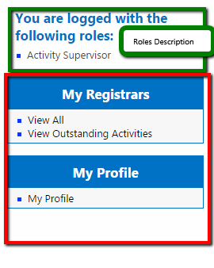

Edit ‘My Profile’ information
- Go to My Profile -> My Profile and Click “My Profile”
- Fill in the form with the information you want to update and Click “Update Profile”
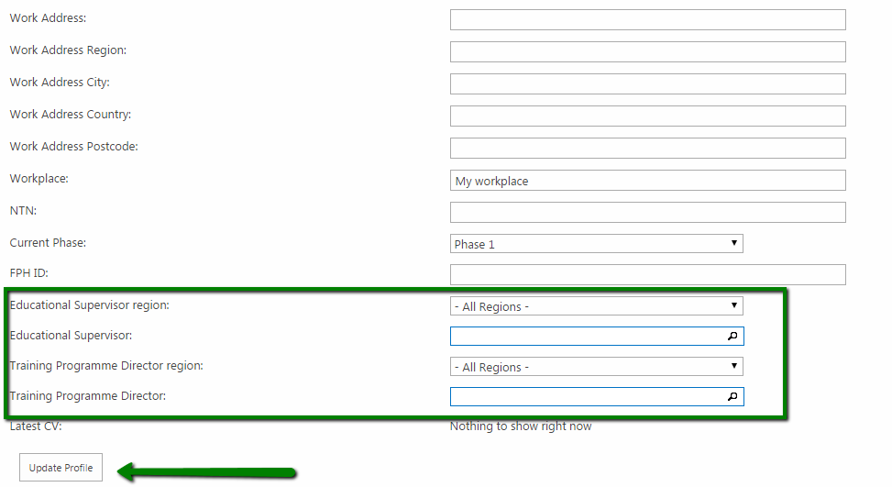
- If the no ‘Educational Supervisor’ or ‘Training Programme Director’ are set in the profile the system does not allow to update the details showing an error message.

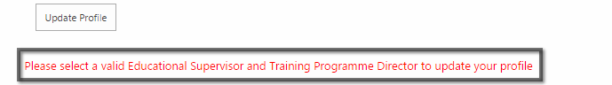
- Set as TPD and ES in the profile the user ‘’System SU” from typing “System SU” in the “Educational Supervisor” and “Training Programme Director” fields.
Once these fields are set this form can be updated at any time.
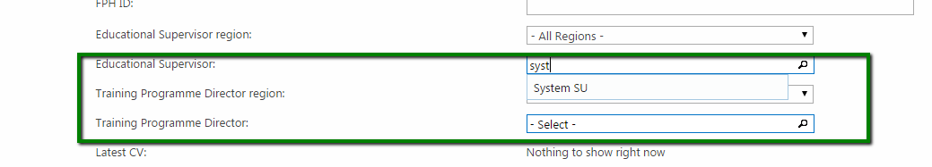

Approve an Activity
- Go to My Registrars -> View All and Click “View All”
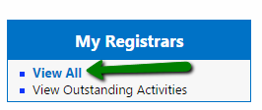
- Navigate through the list of registrars which assigned you as “Activity Supervisor” in their activities. By using the expand button the tree view will expand showing a list of all the activities submitted by the Registrar.
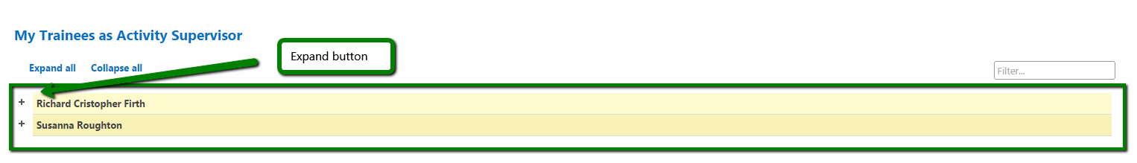
- Click the particular activity name you want to examine to be redirected to the particular activity detail.
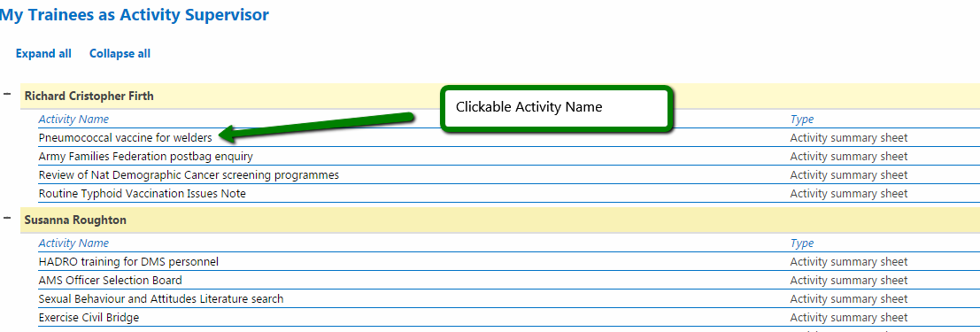
- Examine the “Activity detail” section and “Relation section”.

Activity detail section 1
In the “Activity detail” section it is possible to view all the fields populated by the Registrar such as the ones in the “Activity summary section”. From clicking “View Registrar Profile” button, it is possible to view in a modal window the personal information related to that particular Registrar.

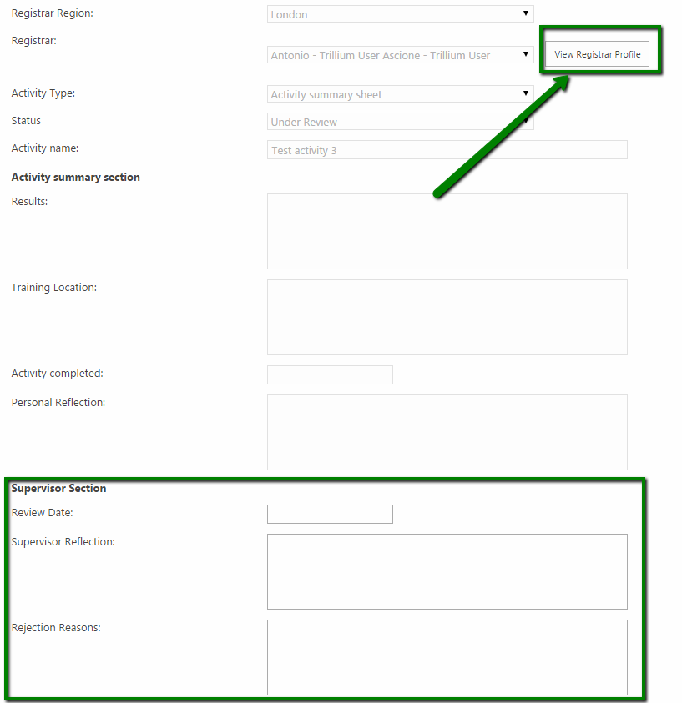

Activity relations section 1
The “Activity Relations” section show all the relations between the activity, evidence (viewable by clicking the Evidence name) and Learning Outcomes (expandable by using “Expand All” button)
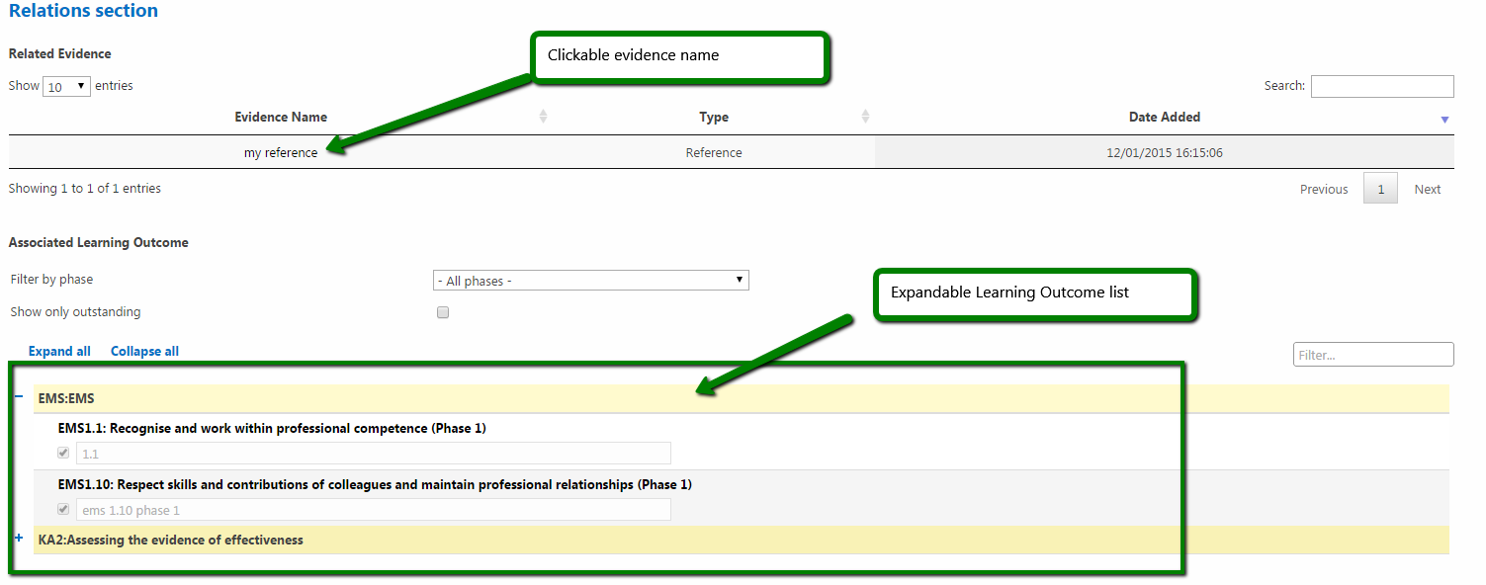
- Complete the form fields “Review Date” and “Supervisor Reflection”
- Click the “Approve” button underneath the “Registrar Activity Item” title.
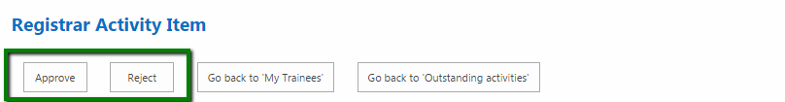

Reject an Activity
- Follow the steps from 1 to 4 (included) in the Approve Activity process
- Complete the form fields “Review Date” and “Rejection reasons”
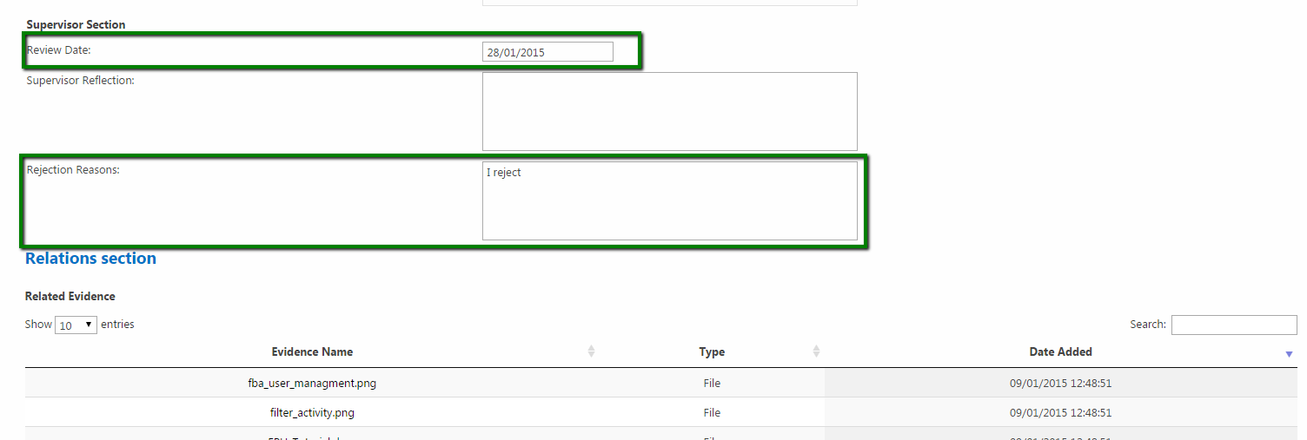

- Click the “Reject” button underneath the “Registrar Activity Item” title.

View an Evidence
- Follow the steps from 1 to 4 (included) in the Approve Activity process.
- In the Relation section-> Related Evidence Click on the particular evidence name to view the details of that particular Evidence.
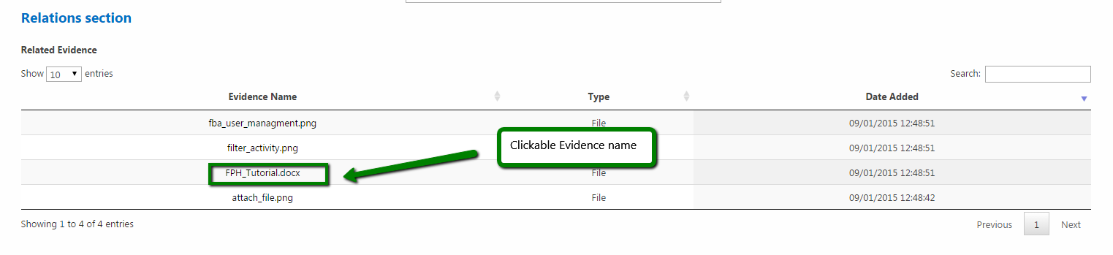
- The modal window related to the particular Evidence item allows you to download the file, if the Evidence type is a file. Click “the file icon“ to download the file and wait until the process is complete

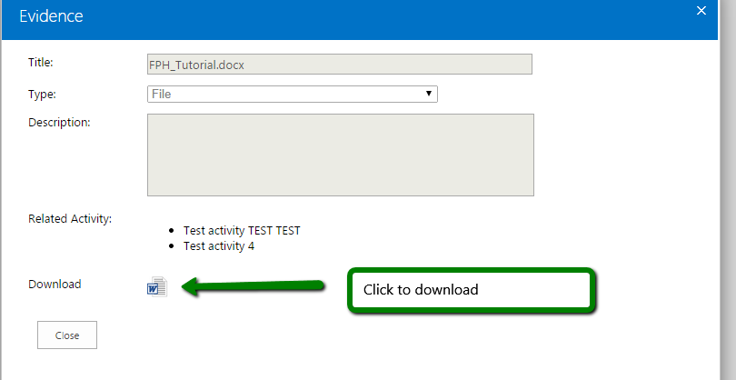

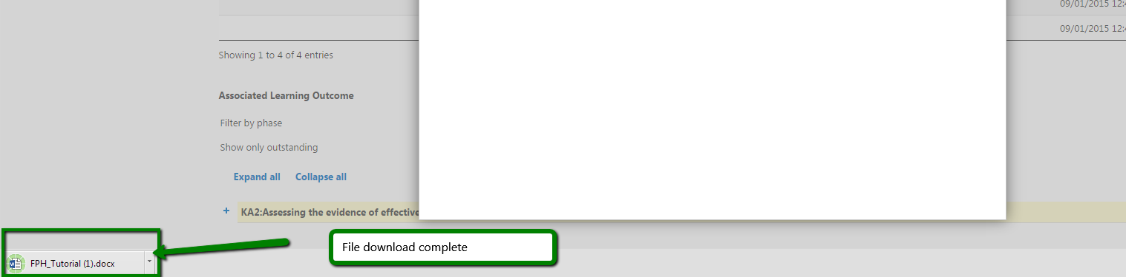

- Alternatively Right-Click on the file icon then Click “Save link as...”
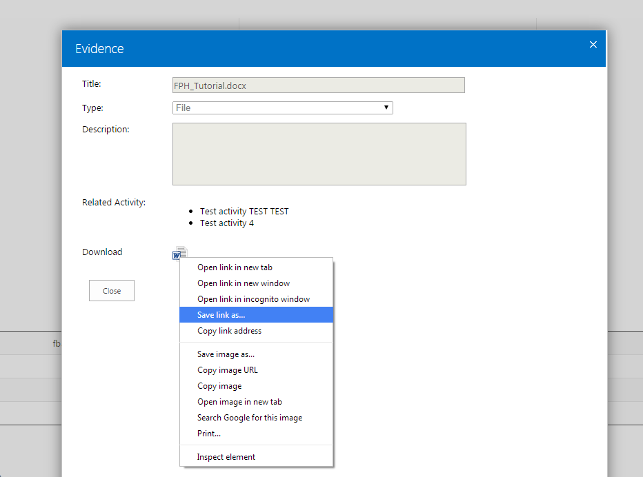

View/Approve/Reject an Activity from “View Outstanding Activity”
- Go to My Registrars -> View All and Click “View Outstanding Activities”
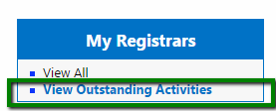

- The current table shows all the Activity items assigned to your user profile as “Activity Supervisor” that needs to be “Approved” or “Rejected”. The table is completely sortable by clicking any of the headers and items can be filtered by user the “Search bar” in the top-right corner.

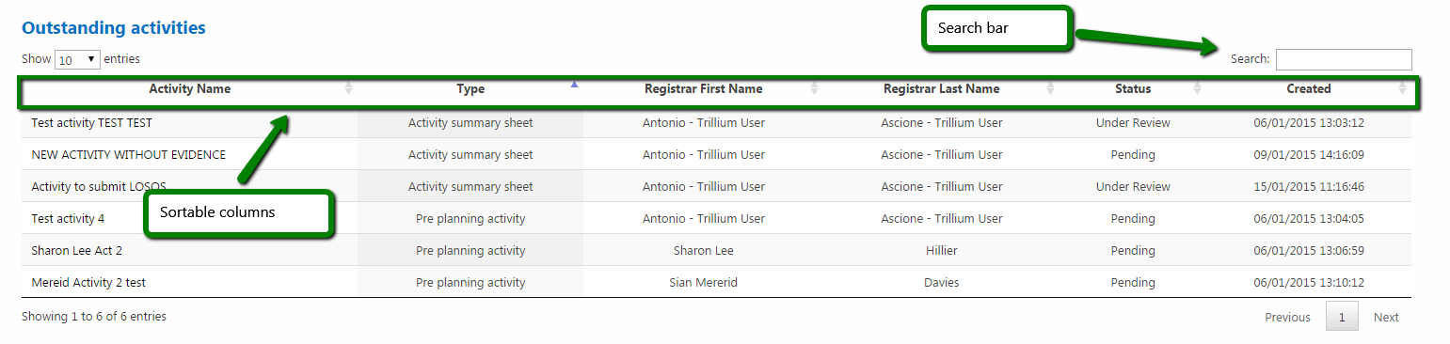
- Once identified the activity you want to view/approve/reject, Click on the particular “Activity Name” to access the “Registrar Activity Item” section.

Outstanding Activity 1
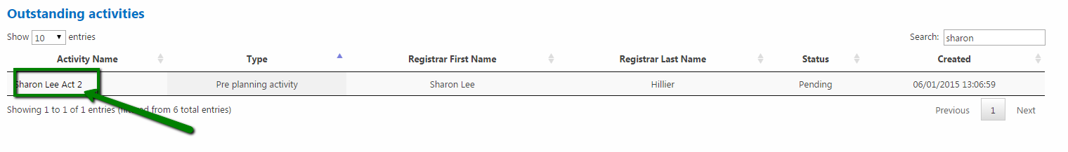

Registrar Activity item 1
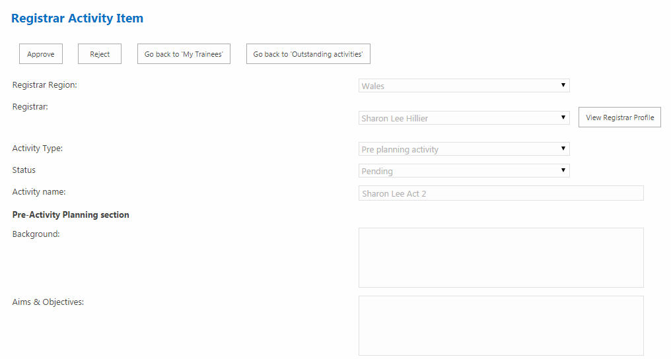
Educational Supervisor

General overview Left Bar menu
Depending on the user role related to the personal profile the left bar menu shows 3 separate sections (‘Learning Outcomes’, ‘ARCP’ and ‘My Profile’) and a message showing the roles associated to the user.
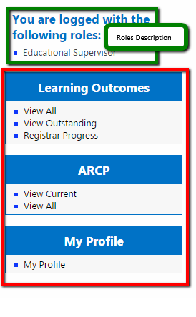

Edit ‘My Profile’ information
Follow the same steps as per “Activity Supervisor”

Approve a LOSOS
- Go to Learning Outcomes -> View Outstanding and Click “View Outstanding”
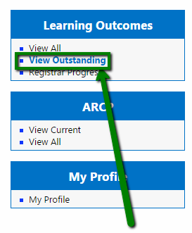
- Click the particular row related to the item you want to approve. The list is sortable by clicking on the headers and items can be filtered by using the “Search” box in the top right corner
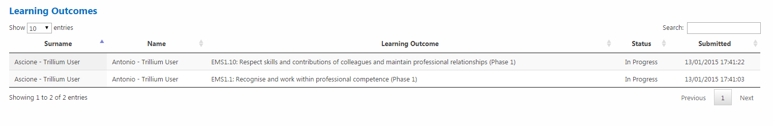
- The LOSOS consists of a main section and a “Project undertaken section” which is shown by checking the “Show project undertaken section” tick-box
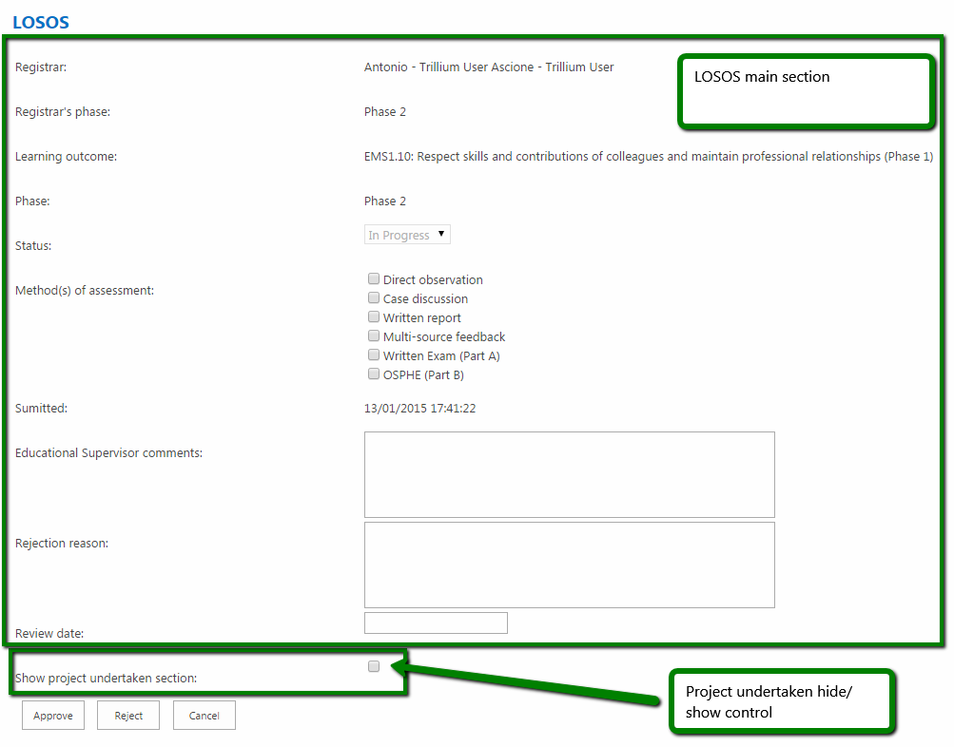

- Click “Show project undertaken section” tick-box to view all the Activity items associated to the current LOSOS and all the Evidence items linked to each Activity item in an expandable tree-view list
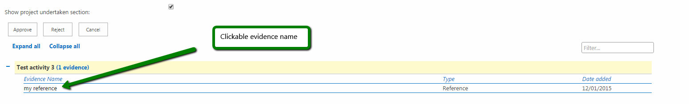

- Click one of the items underneath the “Evidence name” header for a specific Activity item to view in a modal window the details of that particular Evidence.

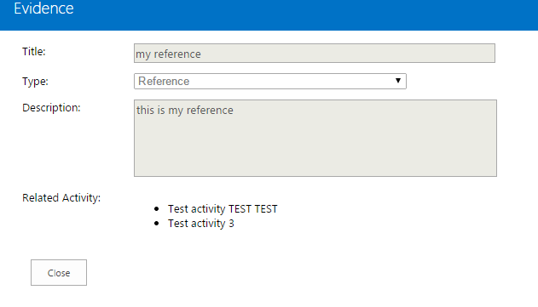
- Complete the “Educational Supervisor comments” and “Review date” fields and select the methods of assessment, then Click “Approve”
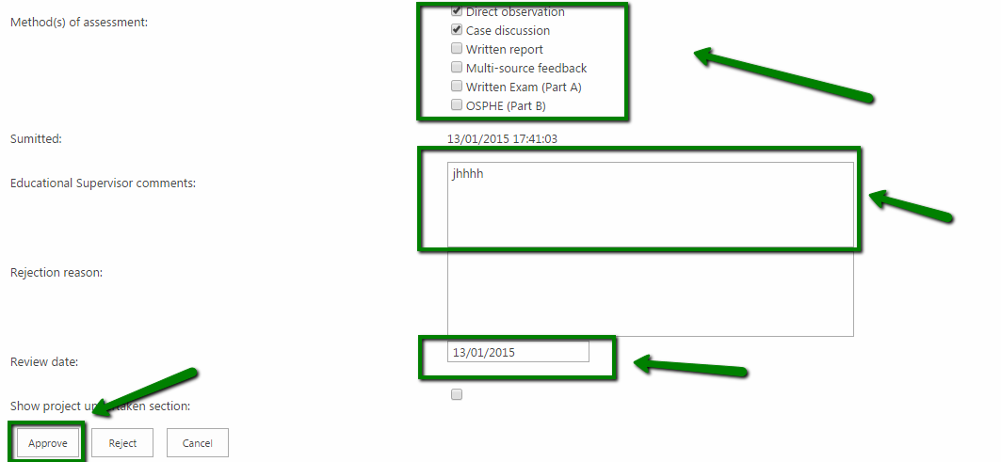

Reject a LOSOS
- Follow the steps described in the “Approve a LOSOS” process from 1 to 5 (included).
- Complete the “Rejection reason” and “Review date” fields, then Click “Reject”
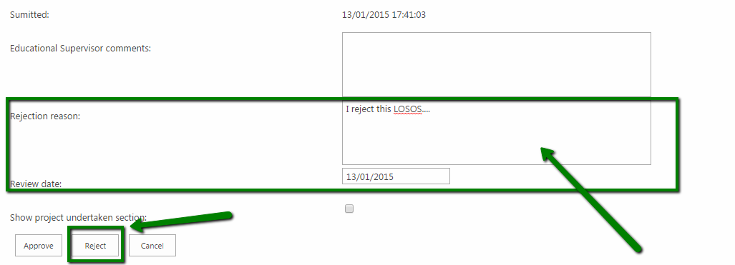

View/Approve/Reject a LOSOS using “View All”
- Go to Learning Outcomes -> View Outstanding and Click “View All”
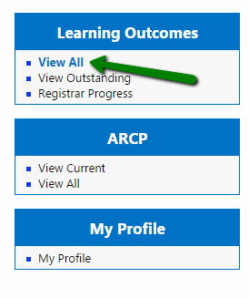
- The resulting table shows all the LOSOS submitted by the Registrars to your user as in the previous process description including the ones in the “Approved” status.
As explained before the table is sortable, the items searchable using the “Search” box and by clicking a row you will be redirected on the particular item for view/approve/reject.
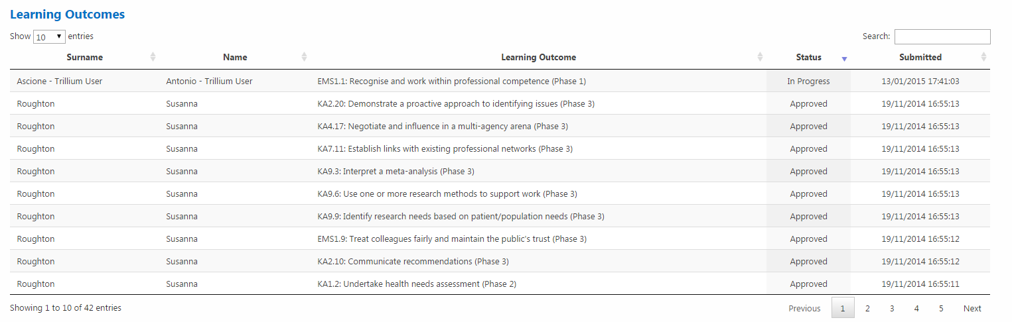

View the Registrar Progress
- Go to Learning Outcomes -> Registrar Progress and Click “Registrar Progress”
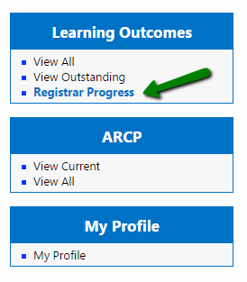
- The “Registrar progress” table shows all the Registrars which LOSOS items have been submitted to your user. Like the other tables with this structure the items are sortable by using the table headers and searchable by using the “Search” box.
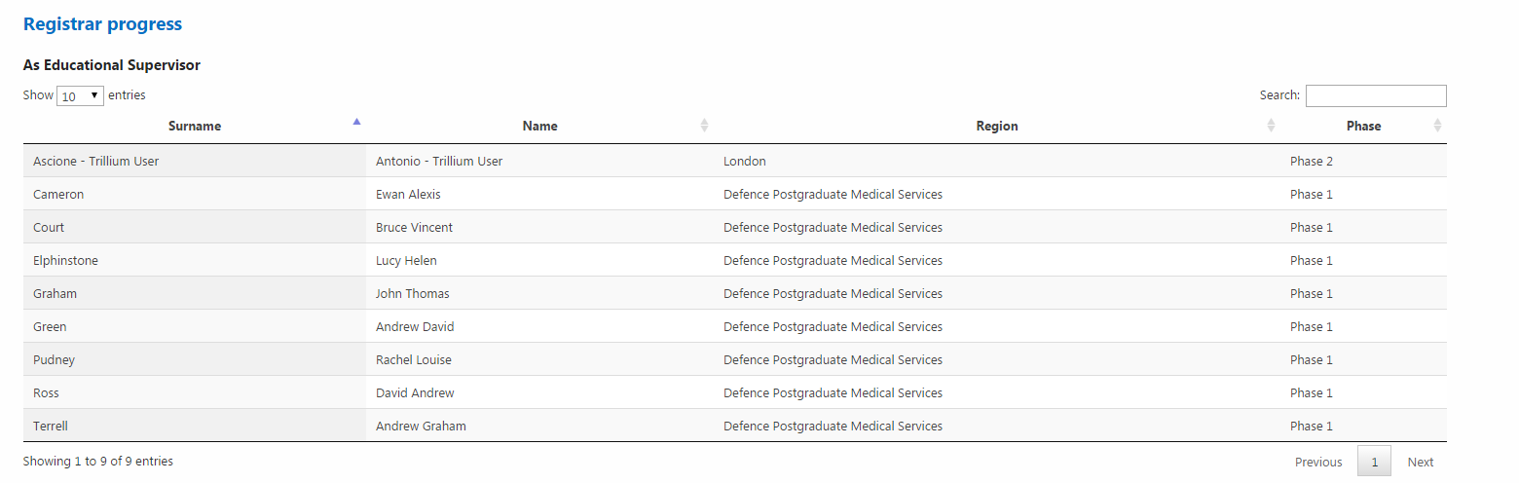
- Click one of the items to be redirected to the particular “Registrar progress details” page.
The LOSOS items which have been submitted (if exist) can be viewed by clicking the “View Submitted LOSOS” button on the right side of each Learning Outcome.
The filter section allows you to filter all the Learning Outcomes regarding the status and/or phase.
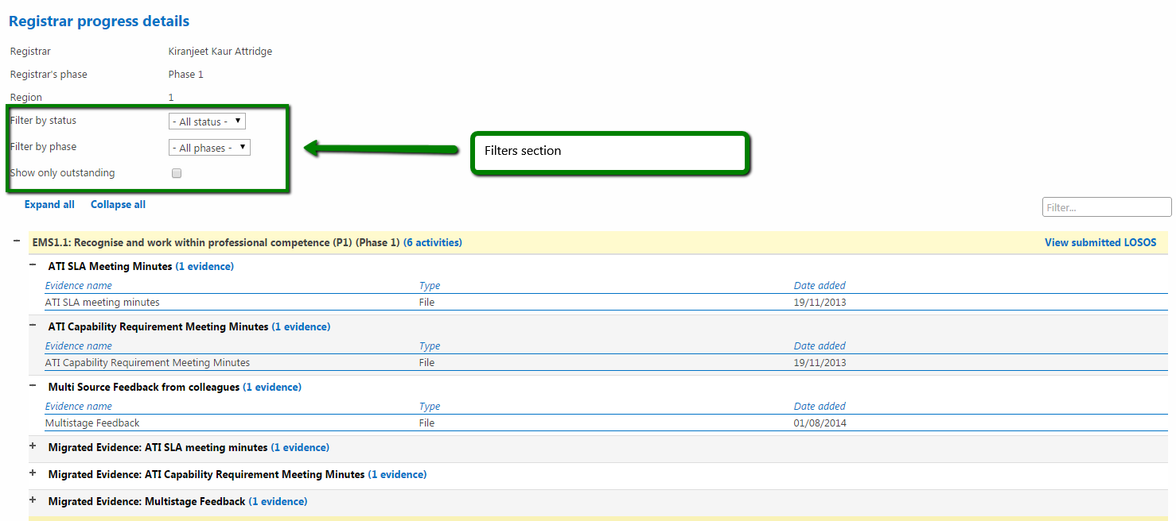
Filter by status overview:
- “Under Review”: LOSOS submitted by the Registrar and in “Under Review” status
- “In Progress”: LOSOS submitted by the Registrar and in “In Progress” status
- “Signed Off”: LOSOS submitted by the Registrar and in “Accepted” status
Please notice that the ”Under Review” and “In Progress” status are “conceptually” to be intended the same status but are separate due to migration constraints from the old system

- Click “View submitted LOSOS” related to a specific Learning Outcome.
This modal window shows the basic information related to the LOSOS in “read only mode” and allows the Educational Supervisor to have a general overview of the situation progress-wise of the Registrar. The “approval/rejection” process for a LOSOS associated to a Learning Outcome must follow the “Reject a LOSOS” and “Approve a LOSOS” processes previously explained.
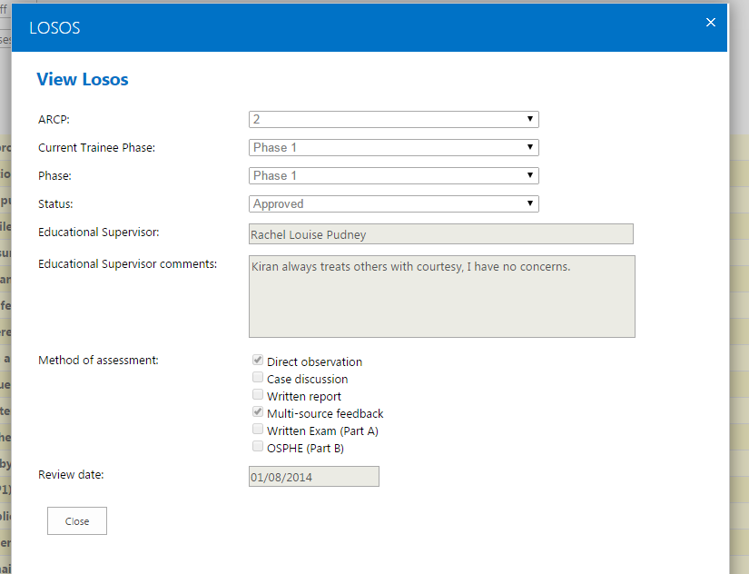

View Current ARCP
- Go to ARCP -> View Current and Click “View Current”
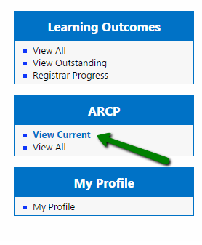
- The “View current ARCP” list shows all the current ARCP items for all the Registrars related to your profile.
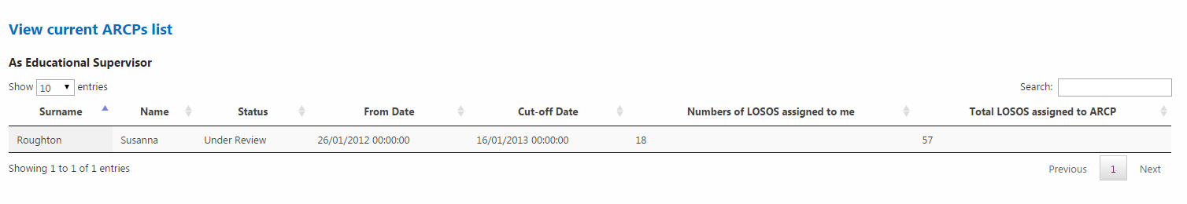

- Click on a particular row to access the particular item.
Each ARCP item page includes:
- ARCP details section: with the generals details related to the ARCP
- Associated reports: where is possible to view/submit/approve/reject the reports related to an ARCP (ESR, ASR and LAF)
- Personal Documents section (not shown in the next image): with the links to the Form-R, Form-4 and CV files uploaded by the Registrar and that can be downloaded by the supervisor.
- Learning Outcomes and relations section: with the all Learning Outcome related to the current ARCP items and all the Activity and Evidence associate to each outcome, with the possibility to view the submitted LOSOS by clicking the “View submitted LOSOS”
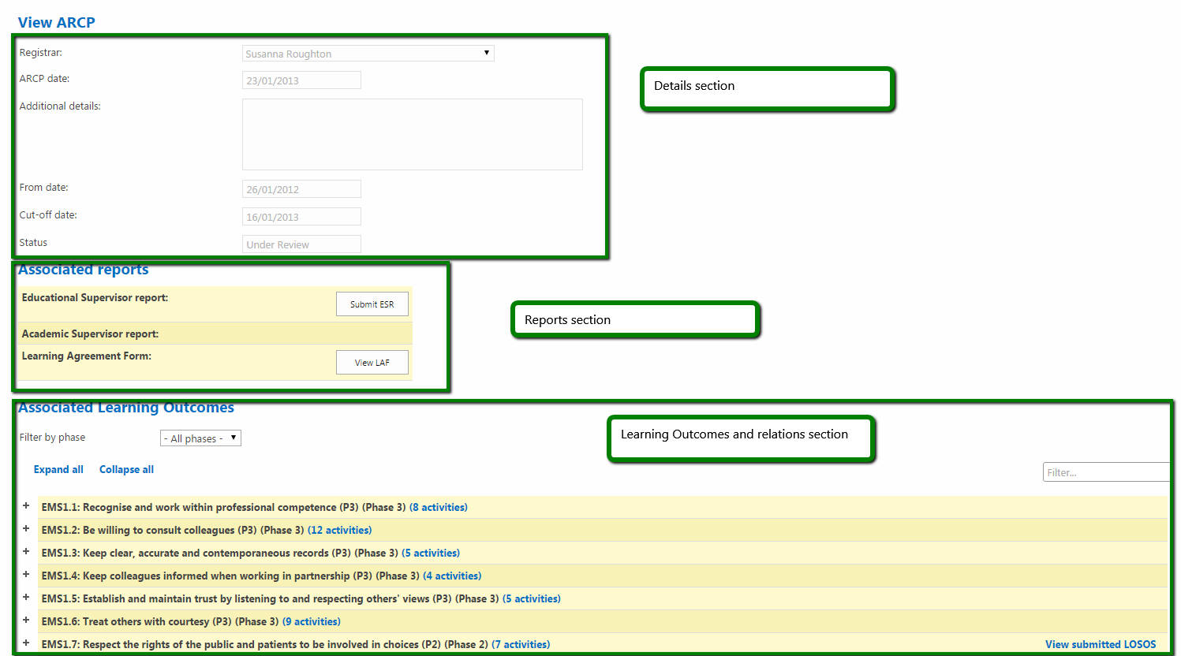

View All ARCPs
- Go to ARCP -> View All and Click “View All”
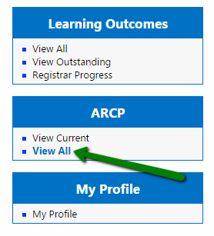
- The “ARCPs” list now includes all the ARCP items submitted the Registrars which LOSOS are related to your current “Educational Supervisor” profile.

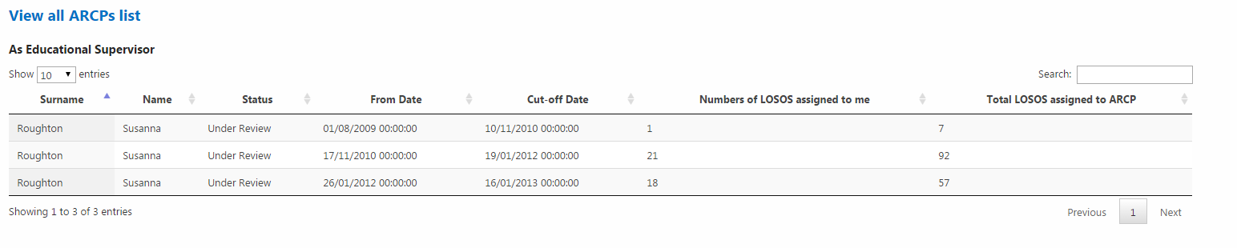

Initiate Educational Supervisor Report (ESR)
- Follow the steps explained in “View Current ARCP” and/or “View All ARCPs” processes to refer to a specific ARCP.
- In the “Associated Reports” section if the ESR has not been already submitted by the Registrar, Click “Submit ESR”.
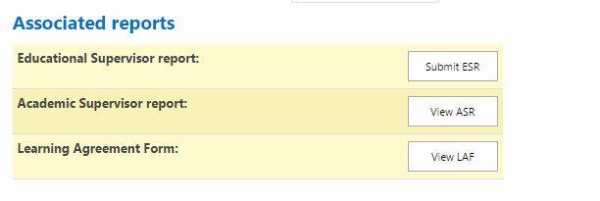

- Complete the form with all the mandatory fields, then Click “Submit ESR” at the bottom of the modal window. If the process is successfully completed the button become “Finalise ESR”.

ESR detail submission 1
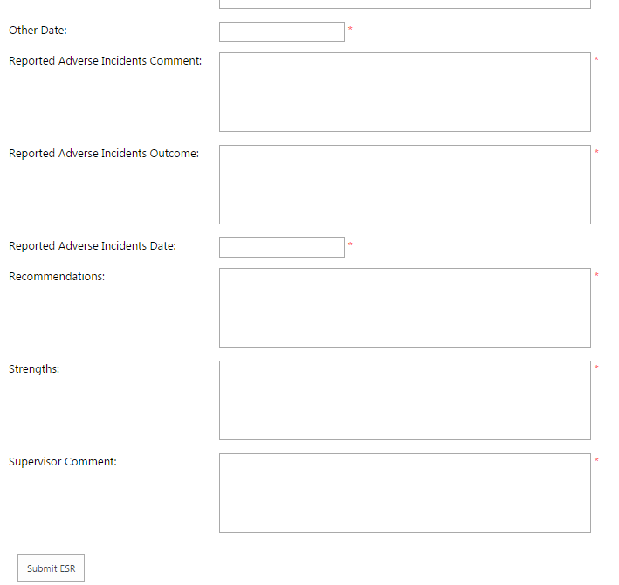

ESR finalise detail 1
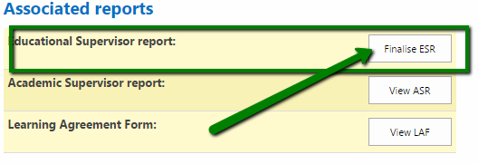
- Click “Finalise ESR”. If the Registrar has not completed his part the modal window will look like this:
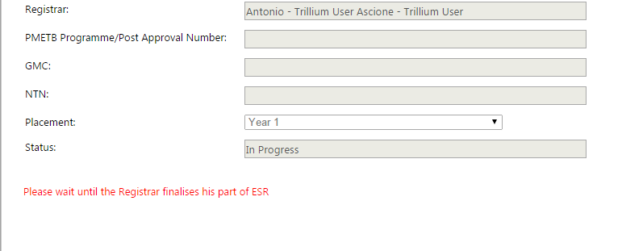

Approve Educational Supervisor Report (ESR)
- Follow the steps in the “Initiate Educational Supervisor Report (ESR)” process 1 to 4 (included).
If the Registrar has finalised his part the modal window will look like this:

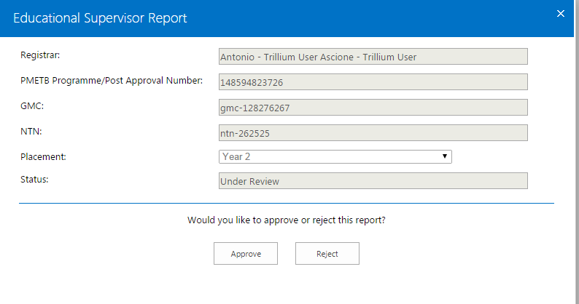
- Click “Approve”, review the fields previously populated on the first submission then Click “Submit” at the bottom of the page
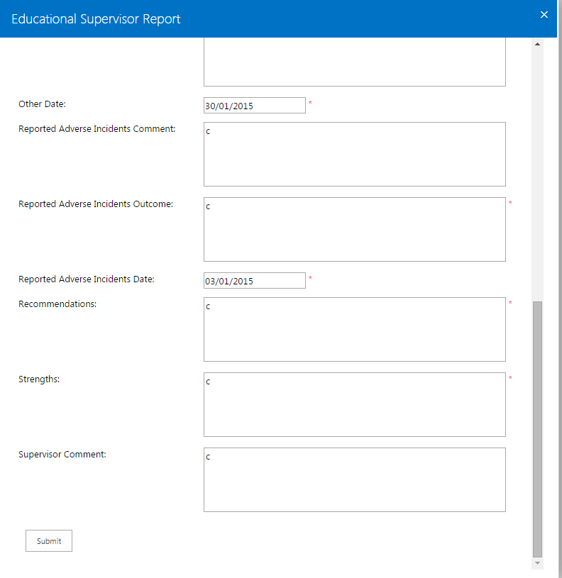
- If the process is successfully completed the ESR becomes only viewable in read/only mode.
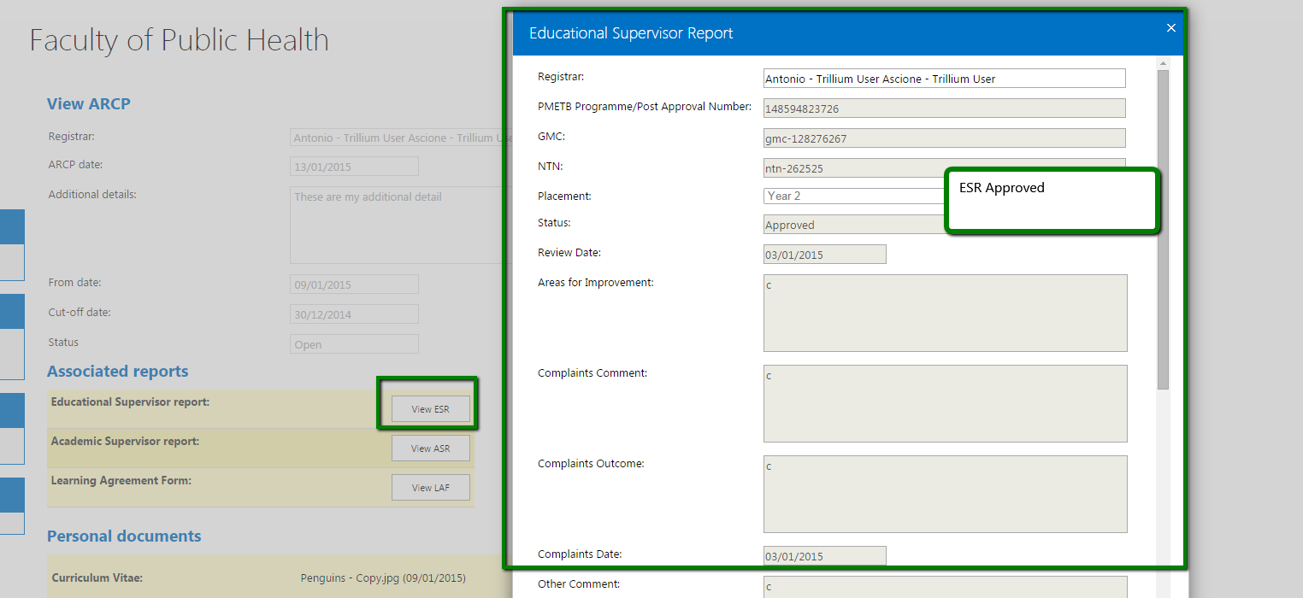

Finalise Educational Supervisor part for a Learning Agreement Form (LAF)
- If your user is one of the assessors for a LAF submitted by a Registrar follow the steps in the “Initiate Educational Supervisor Report (ESR)” process 1 to 4 (included) to refer to a particular ARCP.
- In the “Associated Reports” section related to an ARCP item. Click “Finalise LAF”.
As first assessor Click “Approve” of “Reject” at the bottom of the page.
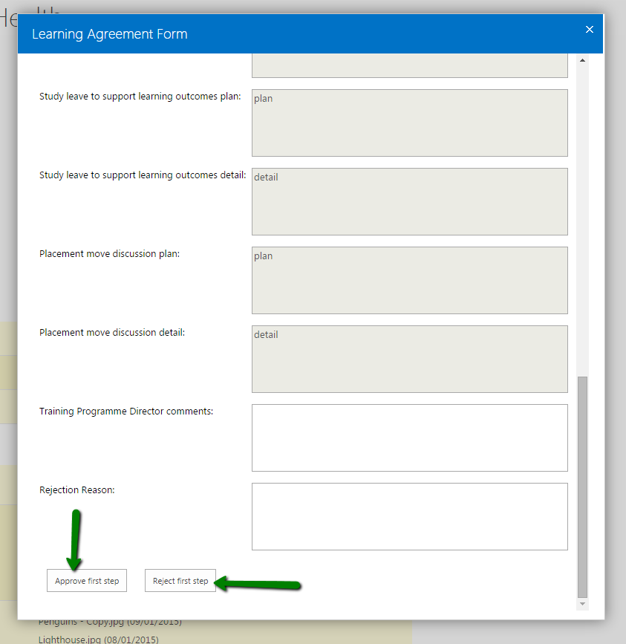

Download CV, Form R or Form 4 for a Registrar
- If a Registrar has submitted single or multiple Form 4, Form R or CVs follow “Initiate Educational Supervisor Report (ESR)” process 1 to 4 (included) to refer to a particular ARCP. The “Personal documents” section of a specific ARCP will appear like this:
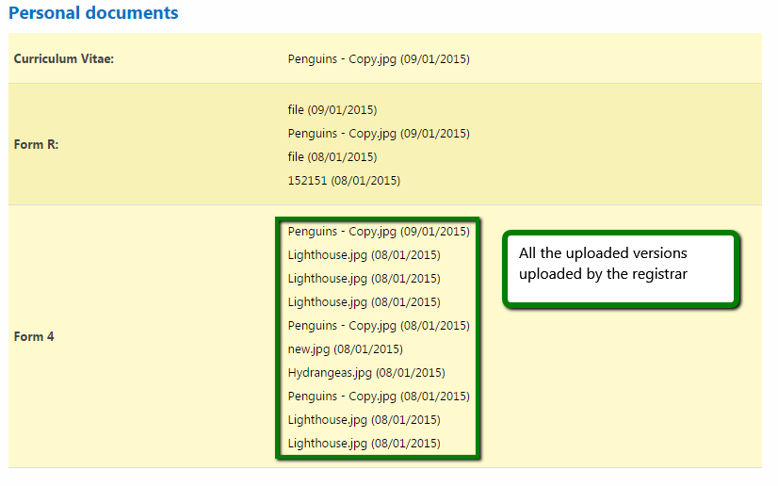
- Click on a specific link to download a specific version of Form R, Form 4 or CV uploaded by the Registrars and associated to the current ARCP.

Training Programme Director

General overview Left Bar menu
Depending on the user role related to the personal profile the left bar menu shows 3 separate sections (‘Learning Outcomes’, ‘ARCP’ and ‘My Profile’) and a message showing the roles associated to the user.
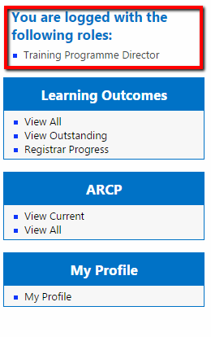
The left-side menu has the same sections as per the Educational Supervisor and the all the forms are viewable in read-only.
Please notice: The Training Programme Director user is able to use all the full functionalities of the Educational Supervisor (Approve/Reject LOSOS) in case in the past has been assigned to them as Educational Supervisor.

Approve/Reject a Learning Agreement Form (LAF)
- If a Registrar has submitted a LAF and your user is one of the assessors of the form (usually the second assessor), follow the steps described in the “Initiate Educational Supervisor Report (ESR)” process 1 to 4 (included) to refer to a particular ARCP.
Click “Finalise LAF”
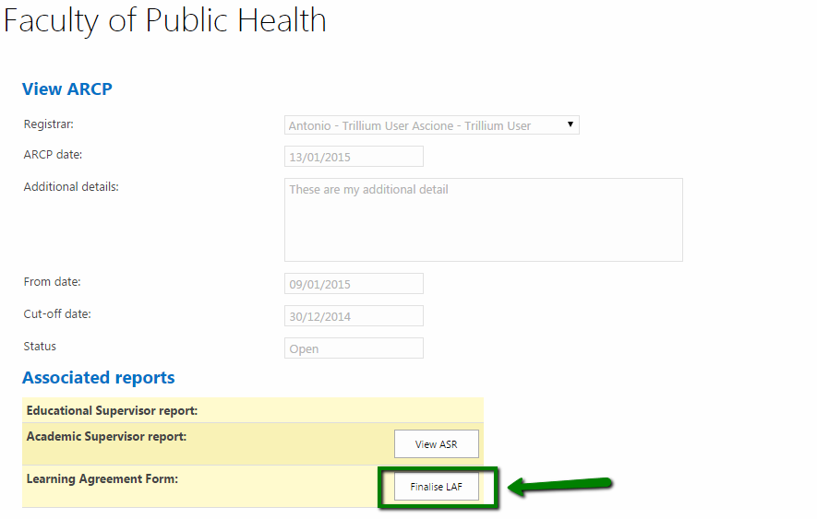
- In the top of the modal window are listed the Registrar name and the first and second assessor full names
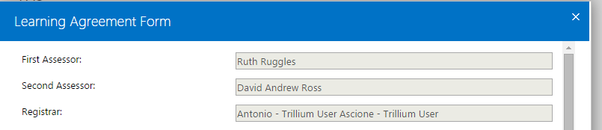
- If your user is the second assessor and the user role associated is Training Programme Director, to approve the form Click “Approve second step” (last approval step) providing some comments in the “Training Programme Director” field.
The form now is approved and there is no need to further approval.

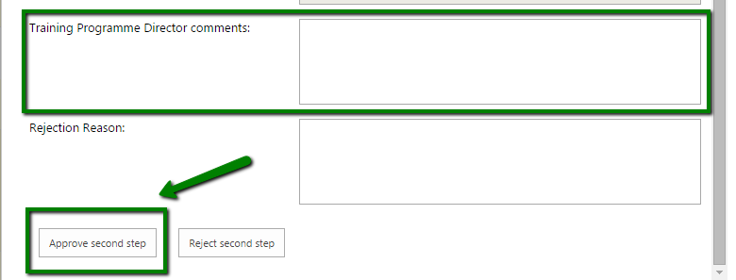

- To approve the form Click “Reject second step” providing some explanation in the “Rejection Reason” field.
The form is sent back to the Registrar to be reviewed and resubmitted.

Academic Supervisor

General overview Left Bar menu
Depending on the user role related to the personal profile the left bar menu shows 2 separate sections (‘ARCP’ and ‘My Profile’) and a message showing the roles associated to the user.

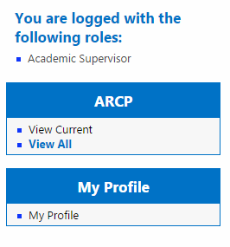

The functionality related to the ARCP and My Profile sections are the same described for the Educational Supervisor and the Training Programme Director.

Approve/Reject the Academic Supervisor report (ASR)
- If a Registrar has submitted a ASR and your has been selected as Academic Supervisor for the report, follow the steps described in the “Initiate Educational Supervisor Report (ESR)” process 1 to 4 (included) to refer to a particular ARCP.
Click “Finalise ASR”
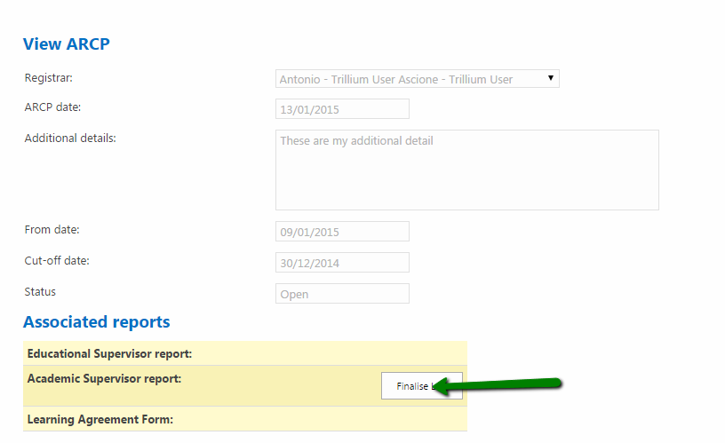
- To approve, complete the mandatory fields than Click “Approve”
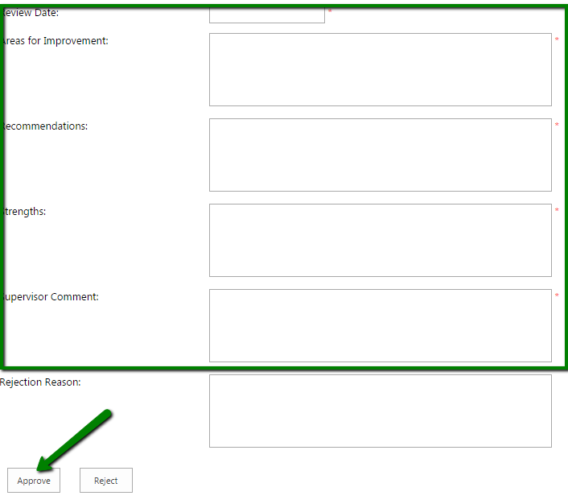

- To reject complete the “Review Date” and “Rejection Reason” fields then Click “Reject”. The report will be sent back to the Registrar for further review.
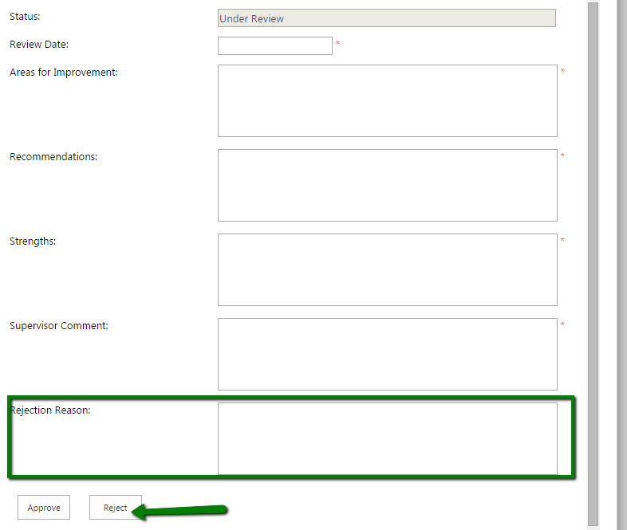

Multiple user role associated to a profile

In case your profile has multiple roles associated the left bar menu inherits all the sections depending on the role.

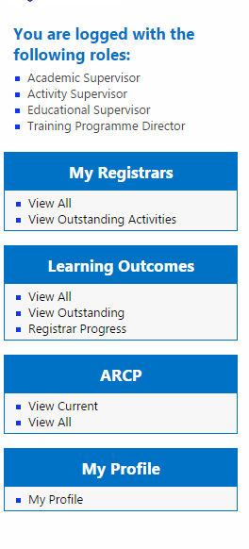

As well as per the left- bar, the whole system will include dashboards and tables according to the roles as in the Registrar Progress page
